Energy questions
Some examples of assessing ideas about energy at age 16

Contents

Purposes of this document 2
Learning intentions and Assessable Learning Outcomes 2
Representing energy ideas 2
Discussions 4
Questions 4
1. Dropping from a high diving board 5
2. Roller coaster 7
3. Pole vaulter 9
4. Archery 12
5. Energy toy 14
6. Lift 16
7. Calorie intake/food 18
8. LED halogen lighting 20
9. Farmer’s power choice 22
10. HEP 24
11. Car/train comparison 28
12. Mobile phone charger 30
13. Specific heat capacity 32
14. Heating a home 34
15. Equilibrium and keeping a house warm 36
Aligning learning intentions and related ALOs for teaching about energy 38
Multiple choice questions 40
Multiple choice question answers 46

Purposes of this document
The questions in this document have been developed by a group of physics teachers and educators for free use in schools.
They can be used to address the new criteria for GCSEs in England. However, they are not intended to replace sample material from the awarding organisations. And, whilst they are set up to work as summative assessment tools, they can be used equally well for formative assessment and discussions with students – whether or not they are studying the English GCSEs.
We sought to develop questions that indicate the kinds of things we might expect students to be able to do with energy ideas at the end of KS4. The aim is to assess their ability to use ideas about energy in calculations, to analyse physical changes and to construct arguments in situations where energy analysis sheds some light on decisions or activities.

Learning intentions and Assessable Learning Outcomes
In developing the questions, we considered what it is that we would like students to know about energy and be able to do with that knowledge. These are the Learning Intentions – based on the York approach to assessment. In order to assess whether the learning intentions have been achieved, we have related them to Assessable Learning Outcomes (ALOs). And, because this document is primarily intended for those teaching and learning GCSE, we have used statements from the GCSE criteria as the ALO where that was feasible.
The table on page 37 shows how the Learning Intentions and Assessable Learning Outcomes relate to each other and to the questions in the pack.

Energy calculations
Energy is a powerful analytical tool because it enables us to do calculations. And, at GCSE level, students are able to get stuck into those calculations. Therefore, many questions will lead up to or be based around a calculation and what that calculation tells us. However, we need some way to present and represent energy ideas to set up those calculations and to allow students to make meaningful comments about them. And it is around those representations (particularly linguistic representations) that much of the recent discussion (on line, at training events etc) has occurred.
In putting these questions together, we found (we hope) some helpful ways of representing energy that does not depend on any particular teaching approach.

Representing energy ideas
We have aimed to use language that is clear but neutral. The questions are structured and phrased in a way that does not rely on any particular teaching approach (either types or stores).
We have tried to devise questions that are:
- comprehensible (should make sense whatever teaching approach you have used);
- illustrative of ways of representing energy in a helpful way;
- describe the physical world in a way that is consistent with other areas of physics.
We found some ways of setting up phrases that we thought were helpful. These are described below. However, the questions are provided in a Word file, so should you wish to substitute some of the turns of phrase, you can. And we are interested to hear reasoned suggestions for better phrasing.

Some examples of what we found

Adjectival energy
In teaching (and texts) it is helpful to try to avoid referring to “xxx energy” (e.g. elastic energy, thermal energy, gravitational energy and so on). The reason being that this implies that energy takes different forms (or that there are different types). It is more helpful to always refer to energy as energy. We found that phrases like “energy stored gravitationally” provide clarity whilst also building a picture that the quantity that is being discussed or calculated is always energy. There was one exception: “kinetic energy” which we have continued to use; “energy stored kinetically” seems too unfamiliar (for now) and seems like a bigger step away from the familiar “kinetic energy” than the others.

Working and work
The GCSE criteria refer to “work done”. In the questions, we have stuck with these terms. We reckoned that whilst the longer construction “Calculate the energy transferred by mechanical working” might be a more helpful picture, it is a lot to absorb in a question (as well as it being different from the term used in the GCSE criteria).
In some of the questions, we include the longer descriptions as well to reinforce the idea that mechanical working is a process and to emphasise the similarity with other processes that transfer energy: electrical working, heating by particles and heating by radiation.

Transfer
This word has been used for some time in energy discussions. In this document, we use it to describe a change in location. I.e. when energy starts out being stored by chemicals in a person’s body and ends up being stored thermally by the surroundings. It has then been transferred from the chemicals to the surroundings.

Discussions

Discussions between teachers (professional development)
It is likely that there are ways of representing energy in this document that may be unfamiliar or would benefit from discussion.
There is a group and topic on Talkphysics where we can have such discussions. All comments and suggestions are welcome.

Discussions with students
It is our hope that these questions will be used formatively and allow for discussions with students. Again, any suggestions for discussions that might be opened up with students are welcome on the Talkphysics forum.

Updates
This document was updated on 12th January 2018

1. Dropping from a high diving board
A woman is practising diving from a 10 metre high platform. Her mass is 60 kg. In her first attempt, she steps off the platform and drops into the pool feet first.
- Use your ideas about forces to explain what happens to her speed as she falls.
- She would like to use an energy analysis to calculate how fast she was going just before she hit the water.
- She chooses the point at which she steps off the platform as a starting point in her calculation.
Which of these would be a suitable end point for her calculation?
- when she is half way down
- just before her feet hit the water
- when she has fully entered the water
- when she is underwater and has stopped moving downwards
- Calculate the decrease in energy stored gravitationally between the chosen start and end point.
- At the end point, the decrease in energy stored gravitationally will be balanced by an increase in her kinetic energy and an increase in the energy stored thermally. To estimate her speed, we can ignore one of these increases.
State which one can be ignored. Explain your reasoning.
- Use your answers to parts (ii) and (iii) to calculate her speed just before she hits the water.
- In her second attempt, she bends her knees and jumps up at the start.
Use ideas about energy to explain whether her speed when she hits the water is bigger, smaller or the same as you calculated in (b).

1. Answers: Dropping from a high diving board
- Her weight (gravitational force) pulls downwards on her; there is an unbalanced force; therefore she accelerates/her speed increases.
- (i) B
- change in energy stored gravitationally
= mass × gravitational field strength × change in height
= 60 kg × 10 N/kg × 10 m = 6,000 J
- We can ignore the increase in energy stored thermally because it is so small. Furthermore, the purpose of the analysis is to calculate v.
- kinetic energy = ½ mv²
6,000 J = ½ × 60 kg × v²
v = 14 m/s
- By bending her knees and springing upwards, she would have dropped from a height greater than the platform;
the energy stored gravitationally at the top of her flight would be greater;
this results in an increased speed at the end of the dive.

2. Roller coaster
Figure 2.1 shows a roller-coaster train at the top of a hill (X).
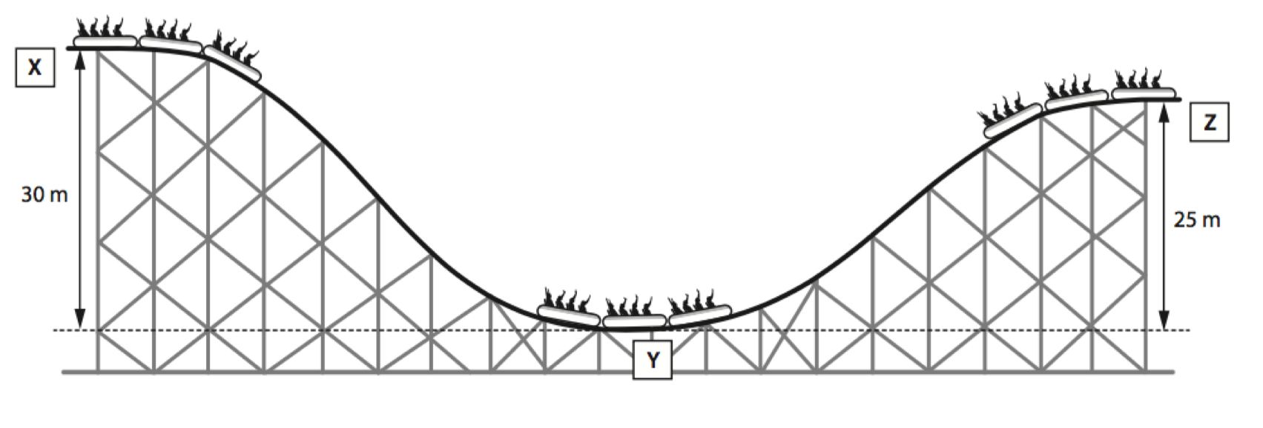Figure 2.1
The rollercoaster train is released at point X, it rolls down the hill to Y and then goes up the other side to Z.
- Look at the table below. Which row describes the change in the way that energy is stored between points X and Y?
Choice | Energy stored gravitationally | Energy stored thermally | Kinetic energy  (energy stored kinetically)
A | Decrease | Decrease | Increase
B | Increase | No change | Decrease
C | Decrease | Increase | Increase
D | Increase | Increase | No change

- The total mass of the roller-coaster and passengers is 2,500 kg. It drops by 30 m between points X and Y.
Calculate the change in energy stored gravitationally between point X and Y.
- (i) Calculate the maximum speed of the cars at the point Y. Show your working.
(ii) Explain why the actual speed of the cars is less than what you calculated.
- Use ideas about the motion of particles to describe why the wheels and axles get hot.
- The rollercoaster continues moving after the bottom of the hill (Y) and travels over the second hill (Z).
(i) Describe the changes to the way the energy is stored between points Y and Z.
(ii) Use ideas about energy to discuss why the second hill must be less than 30m high.

2. Answers: rollercoaster
- C
- decrease in energy stored gravitationally = mgh = 2,500 kg × 10 N/kg × 30 m = 750,000 J
- (i) The decrease in energy stored gravitationally equals the increase in kinetic energy.
750,000 J = ½ mv²
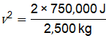
v = 24.5 m/s
(ii) Some energy is now stored thermally. Therefore, kinetic energy is less than the energy that was stored gravitationally at the start.
- There is friction between the bearings and the wheels/axles. The friction makes the particles of the axles and bearings vibrate more vigorously – that is, raising the temperature of the bearings and axles. Energy is transferred to axles and bearings through mechanical working.
- (i) kinetic energy of cars + passengers decreases
energy stored gravitationally (gravitational store of cars + passengers and Earth) increases
energy stored thermally by cars and surroundings increases
(ii) Some of the energy that was originally stored gravitationally will have been transferred to the surroundings and is stored thermally. Therefore, the amount of energy stored gravitationally at the end is less than the amount stored gravitationally at the start. So the car will not reach the same height.

3. Pole vaulter
A pole-vaulter is competing in the Olympics. During her run up she reaches a maximum speed of 9.4 m/s.
To jump over the bar, she pushes the pole into a receiving hole in the ground (figure 3.1). She keeps moving forwards and, in so doing, she flexes the pole. Just before she leaves the ground, the pole is flexed fully and she is stationary.
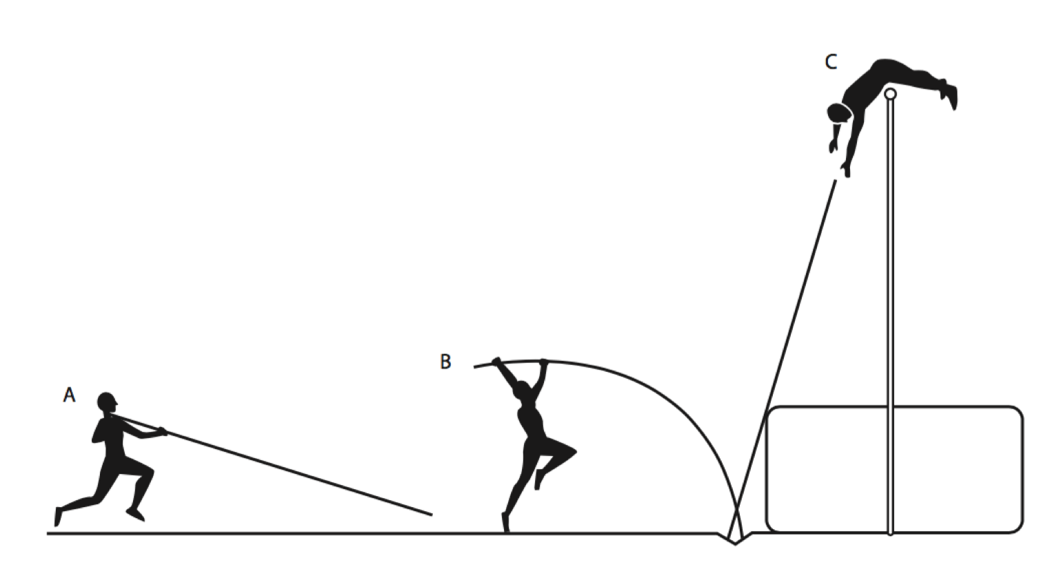
Figure 3.1
She puts the pole into the receiving hole at point A. Point C is the top of her flight as she goes over the bar.
- (i) Which of the following describes the changes to her kinetic energy and the amount
of energy stored gravitationally between points A and C.
Choice | Kinetic energy  (energy stored kinetically) | Energy stored gravitationally
A | Decrease | Decrease
B | Increase | No change
C | Decrease | Increase
D | Increase | Increase

- Calculate her kinetic energy at the end of the run-up.
- She reaches a height of 4.5 m. Her mass is 65 kg.
Calculate the change in energy stored gravitationally as she goes over the bar.
g = 10 N/kg
- Suggest why the energy stored gravitationally is more than the maximum kinetic energy of her run.
- The pole is fully flexed at the point B. Describe the changes in the way that energy is stored between points A and B.
- The world pole vault record has changed more often than any other athletics record. In 1912 it was 4.02 m and in 2014 it was 6.16 m. Much of the improvement is due to changes in the pole (which has been wood, metal and fibreglass).
- Are modern poles better at storing energy elastically than the poles of 1912?
- Explain your answer.
- Use ideas about energy to explain why it is likely that the record will not change so much in the next 100 years.

3. Answers: Pole vaulter
- (i) C
- KE = ½ mv² = ½ × 65 kg × (9.4 m/s)² = 2,872 J
- Change in energy stored gravitationally
= mass × gravitational field strength (g) × height
= mgh = 65 kg × 10 N/kg × 4.5 m = 2,925 J
- She does work when she jumps to launch herself up into the air, when she flexes the pole, and when pushes herself off the pole.
- Her kinetic energy has decreased; the energy stored elastically by the pole has increased; the energy stored thermally has increased.
- (i) It is likely that they are better at storing energy elastically.
- The record has kept increasing and it is likely that this is to do with the properties of the poles rather than improved athleticism.
- Any further improvements would need poles that are nearly 100% efficient. The materials are as good as they are going to be. And people’s speed and strength will change only marginally.

4. Archery
In archery, to fire an arrow, the string of a bow is pulled back until it is fully extended and then it is released.
For the archer to stretch the bow and string, oxygen from the air she breathes is reacted with some of the sugars in her blood. She transfers energy to the bow by mechanical working.
- It is helpful to choose a start point as the moment before the string is pulled back and an end point when it is fully extended.
Which of the following describes the changes in the ways that energy is stored between the start and end points?
- The energy stored gravitationally decreases and the energy stored chemically has increased.
- The energy stored chemically decreases and the energy stored gravitationally has increased.
- The energy stored chemically decreases and the energy stored elastically has increased.
- The energy stored elastically has decreased and the arrow’s kinetic energy has increased.
- The archer uses an average force of 200 N to pull back the string back by 0.6m. Energy is transferred by mechanical working.
Calculate how much work she does.
- State whether the stretched bow and string store less energy, the same amount of energy or more energy than your answer to part (b). Explain your reasoning.
- Now choose the start point to be when the archer is holding the arrow in the stretched bow – just before she fires it; and the end point just after the arrow leaves the string.
Describe the changes in the way energy is stored between the new start and end points.
- The arrow has a mass of 0.02 kg. Use your answers to (b) and (d) to calculate the maximum speed at which the arrow could leave the string.

4. Answers: Archery
- C
- Energy transferred by mechanical working = force x distance
= 200 N × 0.6 m
= 120 J
- The energy stored elastically will be less than the energy transferred by mechanical working (work done) because some of the working will have resulted in a temperature rise in the bow and string.
- When the string is stretched energy is stored elastically; when the arrow is released energy is stored kinetically by the moving arrow (kinetic energy).
- Decrease in energy stored elastically = 120 J
Therefore increase in kinetic energy = 120 J
½ mv² = 120 J
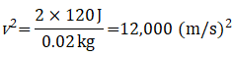
v = 110 m/s

5. Energy toy
Figure 5.1 shows an image of a toy called a jump-up.
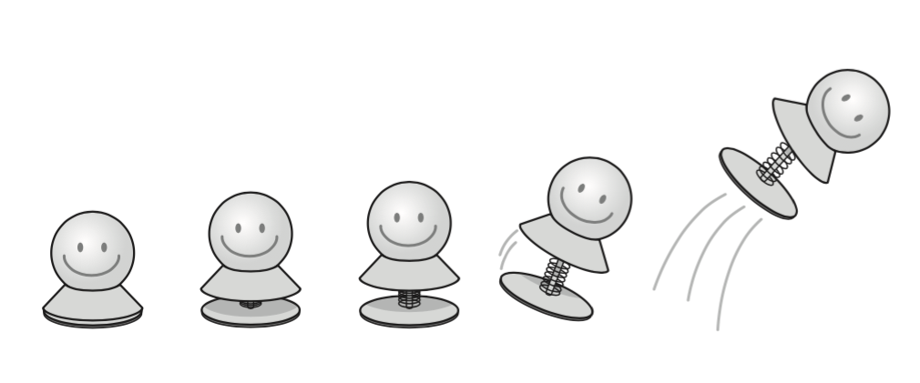
Figure 5.1
When the jump-up is pushed down the top half sticks to the base. When it comes unstuck, the spring expands and the jump-up is propelled into the air.
A student would like to know how fast it is going when it leaves the surface of the table. She is going to use ideas about energy to do the calculation.
She chooses a start point just as the toy leaves the table and the end point when it gets to the top of its flight.
- Think about the changes between the start and end points; state what happens to:
- the kinetic energy of the toy
- the energy stored gravitationally.
- Explain why taking the top of the flight was a good choice for the end point in the analysis.
- She measures the height the toy jumps to as 1.5m. Its mass is 5.0 g.
- Calculate the increase in the energy stored gravitationally between the start and end point.
- Calculate the speed of the toy at the start point (when it left the table)
- In reality, the toy was moving a little faster at the start than the value calculated in part (c). Give a reason for this difference.

5. Answer: Energy toy
- i. KE decreases
ii. Energy stored gravitationally increases.
- The kinetic energy is zero when it reaches the top. Therefore this point allows us to calculate all the energy that has been lost from the kinetic store.
- (i) Change in gravitational potential energy
= mass × gravitational field strength (g) × height
= mgh = 0.005 kg ×10 N/kg × 1.5 m = 0.075 J
(ii) Loss of KE equals increase in energy stored gravitationally
½ mv² = 0.075
v = 5.5 m/s
(d) There was air resistance that would have slowed the toy down
and/or: the toy would have done work against air resistance raising the temperature of the toy and the surroundings. Therefore the energy stored thermally would have increased (as well as the energy stored gravitationally). So the KE at the start must have been bigger than the energy stored gravitationally at the end.

6. Lift
Office buildings often have lifts available to move between floors. However, in Matt’s office, staff are encouraged to use the stairs to move a small number of floors from the ground floor. He decides to work out why this is the case.
He considers the changes for a lift carrying 3 people travelling up 2 floors. The three people have a total mass of 200 kg. The height of each floor is 3 m.
Gravitational field strength = 10 N/kg
- The energy stored gravitationally increases as the lift moves up 2 floors.
Calculate the increase.
- The electricity supply to the office block comes from a gas-fired power station. Before the gas is burned in oxygen, the gas and oxygen store energy.
In order to raise the lift, state whether the amount of energy stored chemically at the power station increases, decreases or stays the same.
- The lift is driven by an electric motor. It transfers energy by electrical working. Its efficiency is 60%.
Calculate the energy transferred by the electric motor to raise the lift between the ground floor to the second floor. Give your answer in joules.
- Suggest reasons why the lift system is not 100% efficient.
- Assume that the lift makes 300 similar journeys over the course of a day. Calculate the energy transferred by the motor during a day,
- in joules,
- in kilowatt hours.
- A kilowatt hour costs 12 p.
- Calculate the electricity costs to the company to run the lift for a day.
- Explain why the electricity company have to charge for the electricity. Give at least two reasons for there being a cost.

- The office managers have displayed the sign in figure 6.1 next to the lift.
In order to climb the stairs, a person depletes their body’s sugars (derived from their food). Although the energy stored gravitationally increases, the process is not 100% efficient. Climbing the stairs is about 30% efficient.
Using the data provided in (c) and here, state whether the statement on the right is correct and justify your answer.
- Suggest why it is a good idea to encourage staff to use the stairs.

6. Answers: Lift
- mgh = 200 kg × 10 N/kg × (2 × 3 m) = 12,000 J
- The energy stored chemically decreases
- ;
energy stored chemically = 20 kJ
- There is friction in the bearings etc; the wires in the motor get hot; the motor is working against these and transfers energy - thereby raises the temperature of its components which then heat the surroundings. The energy is stored in a way that is no longer useful – and is therefore seen as being wasted.
- (i) 20,000 J x 300 = 6,000,000 J (ii) 6,000,000 J/(1,000 x 60 x 60) = 1.7 kwh
- (i) Cost = 1.7 kWh x 12 p/kWh = 20 p
(ii) The cost of the fuel; the cost in running the power station (people’s time); the cost of building the power station; the cost of the distribution network.
- The statement is incorrect. The lift system is, technically, more efficient (60%); human bodies are not efficient at lifting people up – only 30%.
- Good for people’s health; not using electrical system - saves money (though not much); not using electrical system – lower CO₂ emissions; food is a renewable resource whereas the gas used at the power station is not.
The sign would be better saying “Save global resources”.

7. Calorie intake/food
A cyclist has a combined mass (with her bike) of 62 kg. The mountain stage of a race involves a total climb of 1,900 m to the top where the race finishes.
- Which of A, B, C, or D describes the changes in the way energy is stored between the start of the climb and the end of it?
 | Energy stored chemically | Energy stored  gravitationally | Energy stored thermally
 | Increases | Decreases | Increases
 | Increases | Decreases | No change
 | Decreases | Increases | No change
 | Decreases | Increases | Increases

- Calculate the change in the energy stored gravitationally by the cyclist and her bike between the start and end points of the climb. Give your answer in MJ.
- In training, the cyclist has measured her total efficiency when cycling up hill to be 20%.
Calculate the change in energy stored chemically between the start and end point.
- It is recommended that the cyclist consumes food during the race to top up the energy stored chemically in her body. Her favourite is called ‘Energy Zap Gel’. The energy stored by one sachet is given as 365 kJ.
Calculate how many sachets she should consume during the climb.

7. Answers: Calorie intake/food
- D
- Change in gravitational potential energy
= mass × gravitational field strength (g) × height
= mgh = 62 kg × 10 N/kg × 1 900 m = 1 178 000 J = 1.2 MJ
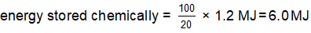
- Depletion of chemical store = 6.0 MJ
Each sachet will refill it by 365 kJ
Number of sachets = 6.0 MJ/365 kJ = 16.4 = 17 sachets

8. LED halogen lighting

Figure 8.1 gives some information about two types of light bulb. When the light is switched on, the circuit transfers energy by electrical working.
Type of bulb | Cost to buy | Power Rating  (W) | Brightness  (lumen) | Running cost for 50 weeks
LED | £3 | 8 | 750 | £2.40
Halogen | £1 | 48 | 750
Figure 8.1
Assume a person has the lights on for 30 hours a week and that electricity costs 20 p per kWh.
- With the halogen bulb in place, calculate the energy transferred by the circuit in 50 weeks.
Give your answer in kWh.
- Calculate the cost of running a halogen bulb for 50 weeks.
- Discuss why it is better to buy an LED bulb compared with a halogen.
Justify your answer with a calculation.
- The manufacturer of the LED bulb claims that it is energy saving.
Suggest what the manufacturer means by ‘energy saving’.

8. Answers: LED halogen lighting
- Halogen: 48 W × 30 hours/week × 50 weeks = 72,000 Wh = 72 kWh
- 72 kWh × 20 p/kWh = £14.40
- The running cost of the LED is £12 less than the halogen bulb. The halogen bulb is £2 cheaper to buy than the LED bulb. The person will save £10 over 50 weeks.
- The LED has the same brightness (lumens) as the halogen bulb but it has a lower power rating; an LED connected to the national grid will use up less energy resource at the power station than a halogen one when run for the same length of time. ‘Energy saving’ means that global energy resources are saved.

9. Farmer’s power choice
A farmer has a field that he wants to use as a renewable energy resource.
He could plant willow trees, a biofuel that can be burnt in power stations. The tree regrows and can be harvested again. The power station burns the fuel to generate electricity for the National Grid.
Once established the field would yield enough material for a power station to make 60 MWh available each year to the National Grid.
Alternatively he could use solar panels. The panels are connected directly to the National Grid.
- Use these examples to explain what is meant by a ‘renewable energy resource’.
- The field measures 400 m x 400 m. A field of solar panels would generate an average power of 5.7 W/m².
- Calculate the area of the field.
- Calculate the average power output of the field if it were covered with solar panels. Give your answer in kW.
- Use your answer to (ii) to calculate the energy provided by the solar power station to the National Grid in a year. Give your answer in MWh.
- Compare the advantages and disadvantages of using the field for solar panels or biofuel.

9. Answers: Farmer’s power choice
- Renewable resources are those that can supply energy without a global energy resource being used up. Biofuels can be cut and will grow again to be harvested another year. Solar panels use sunlight; the Sun will continue to shine for the foreseeable future.
- (i) 400 m × 400 m = 160,000 m²
- 5.7 W/m² ×160,000 m² = 912,000 W = 912 kW
- 912 kW ×365 d ×24 h/day = 7,989,120 kW = 8,000 MWh
- advantages of both are that they are renewable is not worth a mark as is awarded in (a);
Solar panels have a much bigger output.

solar panels:
disadvantages: high capital costs, variable output over day and year;
advantages: low maintenance, can also use the field for other benefits – e.g. grazing sheep, free range poultry, wildflowers – increasing biodiversity

biofuel:
advantages: uses approach familiar to farmer; lower capital costs
disadvantages: monoculture, needs maintenance – weed killer etc, biofuels harvest crop once a year (or less often for willow) so the energy output is not continuous;

10. HEP
A hydro-electric power station generates electricity by allowing water to fall from a high reservoir to a run off 60 m below (figure 10.1). The water turns a turbine which is connected to a generator. The generator is connected to the National Grid to supply electricity to homes and factories.
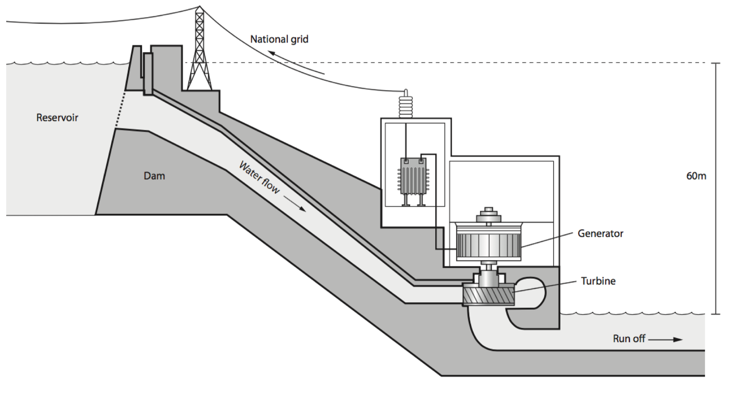
Figure 10.1
During the day, some of the water is allowed to run down the hill, through the turbines, to the lower level.
- State whether the value of each of the following has gone up or down during the day:
- energy stored gravitationally
- energy stored thermally (by the surroundings)
- The power station lets 15,000 tonnes of water run through the turbines in an hour. The water drops by 60 m from the reservoir to the lower level.
1 tonne = 1,000 kg gravitational field strength = 10 N/kg
- Calculate the change in energy stored gravitationally. Give your answer in GJ.
- Calculate the power (in megawatts) of the falling water.
- The electrical output power of the generator is 1.0 MW. What is the efficiency of the generation system?
- The output of the generator is connected to a transformer which steps up the voltage. The transformer gets warm and raises the temperature of the surroundings. It is 98% efficient.
- Calculate the output power of the transformer.
- How much energy is transferred to the surroundings by the hot transformer in a day?
- Given that some of the energy is transferred by heating to the surroundings, describe the advantages of using a transformer to raise the voltage.
- Explain why the slightly warm surroundings are not as useful as an energy source as the water in the reservoir.
- Give two advantages and two disadvantages of a hydro-electric power station as compared with a gas powered power station

10. Answers: HEP

- (i) Energy stored gravitationally has decreased
(ii) Energy stored thermally by the surroundings has increased
- (i) 15,000,000 kg × 10 N/kg × 60 m = 9.0 GJ
(ii) 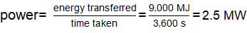
(iii) 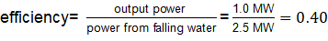
- (i) 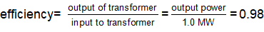
output power = 0.98 MW
(ii) 0.02 MW x (24 x 60 x 60) s = 1.7 GJ
(iii) The distribution system is more efficient if it runs at a high voltage.
There are fewer losses in the wires if the voltage is high and the current is low. And this improvement in efficiency in the distribution system more than makes up for the inefficiency in the transformer.
(iv) The slightly warm air cannot easily be used to do work. Whereas the raised water can.
- Advantages: It is a renewable resource (not using up a global resource).
It has low emissions of carbon dioxide so hardly contributes to increases in carbon dioxide in the atmosphere (and/or climate change).
It can be used to store energy.
Disadvantages: It takes up a large area of land; it is very site-specific, often in remote places, not close to large populations/industry; If there is a drought, it will produce no power.

Blank page

11. Car/train comparison
An electric train is powered by a set of electric motors. Over the duration of a journey lasting 45 minutes and covering a distance of 50 km these motors operate with a total combined average power of 920 kW.
- Calculate the energy transferred during the journey. Give your answer in MJ.
- The electricity is generated by a gas-fired power station. The network for distributing the electricity is 80% efficient. At the power station the gas plus oxygen behaves as a chemical store of energy.
Calculate by how much this chemical store has been depleted by the journey.
- When it is full, the train carries 480 passengers. Calculate how much the chemical store was depleted for each passenger’s journey.
- A small petrol powered car is used to carry a single passenger over a similar 50 km journey. The chemical store for this mode of transport is fuel plus oxygen. The chemicals store 34 MJ per litre of fuel.
During the journey the car burns 3.6 litres of fuel. Calculate how much the chemical store has been depleted by this journey.
- Using your answers to parts (c) and (d), discuss which type of transport, train or car, is more energy efficient in terms of transporting passengers.

11. Answers: Car/train comparison Answers
- Energy transferred by electrical working = power × time = 920 × 10³ W × (45 × 60) s
= 2,480 MJ
- 34 MJ/litre × 3.6 litre = 122 MJ. This is for one passenger.
(e) Figures indicate that a train is more efficient in terms of energy costs than a car for this journey (about 20 times);
Train would not always be full so its energy costs would be greater than the figure calculated.
Car can carry more than one person so when full the energy costs per passenger would be smaller than the figure calculated.
A full car has an energy cost approximately five times more in than a full train.

12. Mobile phone charger
A phone is plugged in to charge the battery (Figure 12.1). The circuit for this is shown in figure 12.2.
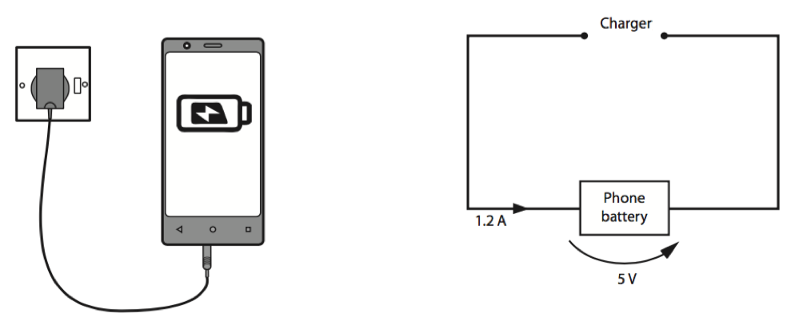
Figure 12.1 Figure 12.2
The potential difference across the battery is 5.0 V and the current is 1.2 A.
During charging, the charger circuit transfers energy to the battery by electrical working. It is noticed that the temperature of the battery rises.
- Calculate the power provided by the charger.
- Calculate the amount of energy transferred in one minute.
- During the first minute, the energy stored chemically by the battery increases by 300 J.
Calculate the efficiency of the charging circuit.
- Assume that no energy is transferred to the surroundings in the first minute.
Calculate the increase in energy stored thermally by the battery.
- The battery has a mass of 28 g and its specific heat capacity is 480 J/kg°C.
Calculate the temperature rise of the battery during the first minute.
- After five minutes, the battery feels hot and is heating the surroundings. Describe in terms of moving particles the way in which the hot battery heats the surroundings.
- One student (Florence) thinks that this energy is lost for ever. However, another student (Alma) points out that energy cannot be lost because the total amount of energy remains the same in any change.
Use your ideas about energy conservation to discuss these two ideas.

12. Answers: Mobile phone charger
- Power = 5 V x 1.2 A = 6.0 W
- Energy transferred by electrical working = 6.0 W x 60 s = 360 J

- Increase in energy stored thermally = 360 J – 300 J = 60 J
- E = m c θ
θ = E/(mc) = 60 J/(0.028 kg x 480 J/kg°C) = 4.5°C
- The particles on the surface of the hot battery are vibrating more vigorously.
They collide with air particles and make them move faster.
The temperature of the air is related to the average kinetic energy of the air particles.
Therefore the temperature rises.
This process is conduction.
g) Alma is correct that energy is conserved.
However, Florence has a point because the energy is stored in a way that makes it less easy to recover.
The temperature of the air is raised only a little bit.
Therefore it is difficult to get the slightly warm air to do any useful work or jobs for us.

13. Specific heat capacity
Two students wish to measure the specific heat capacity of aluminium.
They set up their equipment as in figure 13.1:
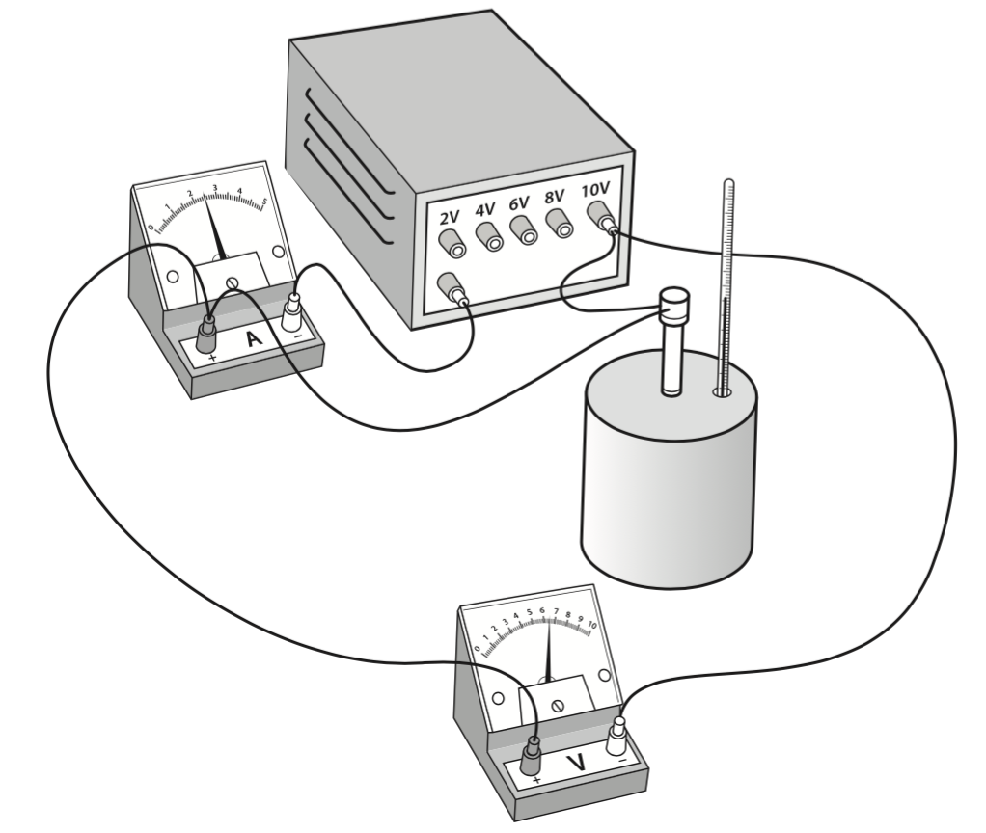
Figure 13.1
The power supply is turned on and the following readings are recorded:
Ammeter: 2.5 A Voltmeter: 6.2 V
- Calculate the power of the immersion heater.
- The voltage on the power supply is increased and the power supplied electrically to the heater is now calculated to be 55 W.
The circuit raises the temperature of the immersion heater by electrical working.
Calculate the electrical work done when the heater is switched on for 600 s.
- The hot immersion heater transfers energy to the block by heating. Its temperature rises from 18°C to 54°C.
The block has a mass of 980 g.
Using the values provided, calculate the specific heat capacity of aluminium.
- One of the students thinks that their method would give a more accurate result if they wrapped their aluminium block in wool. Explain how this might improve their result.

13. Answers. Specific heat capacity
- P = I V = 2.5 A × 6.2 V = 15.5 W
- W = P t = 55 W × 600 s = 33,000 J
- [note depends on previous answer] c = E/m ΔT = 33 000 J/(0.98 kg × 36°C) = 935 J/kg°C
- The hot block transfers energy to the surroundings by heating. Some of this is by contact (conduction). Thermal insulation will reduce the rate at which energy is transferred from the hot block to the surroundings by conduction, so the value of energy used in (c) will be closer to the true value.

14. Heating a home
An Antarctic research base is constructed of ‘habitat modules’ which are occupied all year round. The internal temperature of the modules is kept at a constant 20°C.
The walls of the buildings have very thick layers of expanded polystyrene. These layers have a very low thermal conductivity.
On a summer day the external temperature falls to −10°C.
- Describe the difference in the behaviour of air molecules inside the module compared with air molecules outside of the module.
- The habitat is kept warm using an oil burner. Its output power is set at 3.0 kW.
- State the power loss through the walls of the module.
- Explain why you chose that value.
- State what change would be made to the power setting on the oil burner to maintain the temperature if:
- the thickness of the insulating layer is increased,
- the outside temperature falls to −40°C,
- the daylight hours increase (without any change in outside temperature)
- Explain why heating a module in the Antarctic is much more costly than heating a house of a similar size in the United Kingdom.
- Fuel oil is a non-renewable resource and it has been suggested that the Antarctic base should use a renewable resource to provide heating instead. Solar panels are renewable and can be used to heat houses in the UK.
- What is the difference between a renewable and non-renewable energy resource?
- Suggest why the habitat cannot be heated using electricity generated by solar panels alone.
- The commander of the base suggests that heating costs could be further reduced by wearing ‘thermal clothing’ while inside the base.
Explain how this could reduce costs.

14. Answers: Heating a home
- The molecules inside the habitat module will be moving faster (on average) than the molecules outside the module.
- (i) 3 kW
- The temperature is steady. The power lost through the walls must be the same as the power provided by the heater. It is in equilibrium.
- (i) reduce the power
- increase the power
- no change
- Idea of high costs of transporting the oil to a remote location; idea of larger quantities of oil required due to lower external temperatures than would be seen in the UK.
- (i) Non-renewable resources have a limited supply (will run out) whereas renewable resources are unlimited (will not run out).
- Antarctic is dark for long periods.
- Internal temperatures could be lower, requiring less fuel to maintain the temperature.

15. Equilibrium and keeping a house warm
Jo and Alex live in similar houses and they both have gas fired central heating.
In autumn, Jo sets a timer to switch the heating on half an hour before she gets home. Alex leaves the heating on all day. On a typical day, it is 9°C outside.
Alex says that her method is more energy efficient because the house never gets cold and it takes more energy to heat up the cold house.
Jo says that her method is more efficient because the heating only has to run for half an hour when she gets home. She says it is wasteful of Alex to be keeping an empty house warm

Version 1.
Who is correct? Explain your choice.

Version 2.
The specific heat capacity of air is 1.0 kJ/kg°C.
- The mass of air in Jo's room is 50 kg.
- The radiators transfer energy to the air by heating. Calculate how much energy has to be transferred to raise its temperature from 9°C to 20°C.
- The heater in Jo's room has an output power of 500 W. Calculate the minimum time it takes to raise the temperature of the room from 9°C to 20°C.
- In reality, it takes longer to raise the room's temperature to 20°C. Explain why.
- Alex leaves her 500 W heater on all day. The room reaches a stable temperature of 22°C.
- Explain why the temperature of the room stops increasing when it reaches 22°C.
- State the power at which the room is heating the surroundings.
- It cost 10 p to run the gas central heating for one hour. Calculate how much it costs to come home to a warm room for:
- Jo (whose system switches on for half an hour before she comes home)
- Alex (who is away from home for 8 hours)
- Calculate how much money Jo saves over 200 days.

15. Answers: Equilibrium and keeping a house warm

Version 1
Jo is correct. Her heating is only running for half an hour. Alex's heating is running all day. Because Alex’s room is hotter than outside, it will transfer energy to the surroundings by heating. Most of her heating costs are used to raise the temperature of the surroundings (by a very small amount) while she is out of the house.

Version 2.

- Energy transferred = 50 kg ×1.0 kJ/kg°C × 11°C = 550 kJ
- 550 kJ/500 W = 1,100 s, 18 minutes
- Once the room is at a higher temperature than the surroundings, it starts to transfer energy to the surroundings by heating. Therefore, the heater has to transfer more energy to the room to make up for the energy that is being transferred to the surroundings.

- The room is transferring energy to the surroundings at the same rate as the heater is transferring energy to the room (by heating). The room temperature reaches equilibrium when the power in equals the power out.
- 500 W
- (i) 0.5 hr x 10 p/hr = 5 p
(ii) 8 hr x 10 p/hr = 80 p
(iii) 200 x (80 p – 5 p) = 15,000 p = £150

Aligning learning intentions and related ALOs for teaching about energy
Broader learning intentions not explicitly assessed:
- Get an insight into the sciences as analytical approaches

Learning intention | Qs | Related assessable learning outcomes (including GCSE criteria in italics)
Be able to answer questions that are illuminated by an energy analysis:  - Understand that when a system changes the way energy is stored may change.  - Be able to suggest (and carry out) calculations to support an energy analysis | 1, 2, 3, 4, 7, 9, 11, 7, 12, 13 | - describe all the changes involved in the way energy is stored when a system changes, for common situations: appropriate examples might be an object projected upwards or up a slope, a moving object hitting an obstacle, an object being accelerated by a constant force, a vehicle slowing down, boiling water to boil in a kettle  - describe with examples where there are energy transfers in a system, that there is no net change to the total energy of a closed system (qualitative only)  - calculate the amounts of energy associated with a moving body, a stretched spring, and an object raised above ground level  - describe and calculate the changes in energy involved when a system is changed by heating (in terms of temperature change and specific heat capacity), by work done by forces and by work done when a current flows  - make calculations of the energy changes associated with changes in a system, recalling or selecting the relevant equations for mechanical, electrical, and thermal processes; thereby express in quantitative form and on a common scale the overall redistribution of energy in the system  - identify start and end points that are useful for carrying out analysis using energy ideas  - compare the starting with the final conditions of a system and describing increases and decreases in the amounts of energy associated with movements, changes in positions in a field  - describe and calculate the changes in energy involved when work is done by forces  - rearrange kinetic energy equation and calculate final speed of falling body  - compare different methods of transport in order to discuss their ‘efficiency’ in transferring people through similar journeys.  - apply the principle of conservation of energy to a system involving food and the effects of physical exercise.
Understand that in all system changes, energy is dissipated, so that it is stored in less useful ways. | 2, 4, 7, 8, 11, 12, 13, 14 | - Describe, with examples, how in system changes, energy is dissipated, so that it is stored in less useful ways.  - Describe and explain ways of reducing unwanted energy transfer e.g. through lubrication, thermal insulation; describe the effects, on the rate of cooling of a building, of thickness and thermal conductivity of its walls (qualitative only)  - calculate energy efficiency for any energy transfer
Understand that electricity is a convenient way of transferring energy over large distances; | 8 | - Explain the relationship between energy dissipated by an appliance and the energy stores at a power station
Understand how electric circuits are used to transfer energy by electrical working; through electrical working, electrical appliances can be used to lift things, drive things, and produce a temperature rise; the rate of (electrical) working of an appliance is measured in W and kW, the work done is measured in J or kWh. | 8, 9, 11 | - Explain, with references to examples, the definition of power as the rate at which energy is transferred.  - Use the equation power (W) = potential difference (V) × current (A)  - Use the equation energy transferred (J, kWh) = power (W, kW) x time (s, h)  - Calculate the cost of running an electrical appliance.
Understand the global and local challenges related to energy resources | 9, 14 | - describe the main energy sources available for use on Earth (including fossil fuels, nuclear fuel, bio-fuel, wind, hydro-electricity, the tides and the Sun), compare the ways in which they are used and distinguish between renewable and non-renewable sources
Understand the idea of equilibrium temperature, that the power out equals the power in. | 14 | - Explain why energy is needed to maintain a constant temperature

Multiple choice questions

1. We use electricity to run devices in the home. Which of the following best describes the reason for doing so?
- Electricity is renewable.
- Using electricity is free.
- Using electricity results in no carbon emissions.
- Using electricity is convenient.
2. An electric kettle is run for 2 minutes to boil some water. Which of the following gets used up during those two minutes?
- fuel at a power station
- electricity
- electrical energy
- carbon
3. Which of the following describes the original source of the chemicals that store energy in your body?
- food
- blood
- food plus oxygen
- carbon dioxide
4. The typical energy value of the food that a 16 year old eats in a day is 9 MJ. Which of these is closest to the typical average power developed by a 16 year old?
- phone charger: 4 W
- laptop computer: 40 W
- bright light bulb: 100 W
- kettle: 1,000 W

5. When hands are rubbed together, their temperature goes up. Which of these describes the process that lead to the temperature rise?
- Working against the frictional forces raises the surface temperature.
- Heat is generated by friction.
- The frictional forces convert work to heat in his hands.
- Chemical energy is converted to heat energy.
6. The local swimming pool opens between 8 am and 8 pm. During opening hours the pool is kept at 28ºC by a thermostat. The gas-fired water heater is switched off at 7 pm and switched on again at 5 am.
(i) Which of these is the most likely reason for switching off the heater overnight?
- It is unsafe to run the heater when no one is around.
- Gas costs more at night.
- It is wasteful to keep the water warm when no one is swimming in it.
- It prevents bacteria growing in the water.
(ii) Which of these is the best explanation for switching off the heater an hour before closing?
- The water stays warm enough for the final hour.
- It stops carbon dioxide building up.
- The pool is busier in the evening and the water might get too hot.
- It allows the maintenance staff to go home earlier.
(iii) Which of these is the best explanation for switching the heater on 3 hours before the pool opens?
- to make sure that the heaters are working
- to clean the pipes before people arrive
- to kill any bugs that might have landed in the pool
- to allow time to raise the temperature of the water

(iv) It is suggested that it would be more efficient to keep the water warm overnight because it would then use less gas to raise its temperature in the morning. Which of these is the best response to the suggestion?
- It would take even more gas to keep the water warm overnight when no-one is in the pool.
- The gas boiler has to have some down-time to recover overnight.
- The water will still cool down because it is colder at night.
- There is so much water in the pool that it won’t lose any energy.
(v) Running the gas boiler for a day reduces the amount of energy stored chemically. Which of these best describes the chemicals that store energy for the gas boiler?
- gas plus carbon dioxide
- oxygen plus carbon dioxide
- gas and electricity
- gas plus oxygen
(vi) During the day, the amount of energy stored chemically decreases. How is the energy which was originally stored chemically stored at the end of the day?
- thermally by the water only
- thermally by the water and the surrounding air
- chemically by the people who swam in the pool during the day
- chemically in the water
(vii) The energy that was originally stored chemically has been dissipated. Which of the following is the best description of the term ‘dissipated’?
- The energy has been used up.
- The energy is stored in a way that is less useful.
- The total energy was not conserved.
- The carbon dioxide produced will contribute to global warming.
7. An electric kettle is switched on for 1 minute. The house is supplied by a gas fired power station.
(i) Which of the following describes the changes in the way that energy is stored after the kettle has boiled compared with beforehand?
- Electricity has been used up to increase the energy in the system.
- Electrical energy has decreased to produce sound and heat.
- Solar energy is used to produce electricity, which is turned into heat.
- A chemical store has been depleted and the energy stored thermally has increased.
(ii) Which of the following describes the energy processes in the circuit?
- Electricity produces heat in the kettle’s element.
- The circuit transfers energy to raise the temperature of the element and water.
- There is a chemical reaction in the element that heats the water.
- The element creates energy, which passes into the water.
8. The typical average power requirement of a house is 500 W. Which of the following is the electrical energy requirement over a day?
- 6 kWh
- 12 kWh
- 75 kWh
- 200 kWh
9. A typical household electricity bill is many hundreds of pounds a year. Which of the following is not something that the householder is paying for?
- fuel at a power station
- people’s time working for the company
- electrical energy
- maintenance of the distribution network

10. A skateboarder uses a ramp to perform stunts. The ramp is 5 metres high. She starts at the top of the ramp and accelerates down. She wants to find out how fast she is going at the bottom of the ramp.
(i) Ignoring friction, which of the following is the most useful description of the energy changes between the top and bottom of the ramp?
- The energy stored gravitationally decreases and her kinetic energy increases.
- The energy stored chemically decreases and the energy stored gravitationally increases.
- The kinetic energy decreases and the energy stored chemically increases.
- The energy stored chemically decreases and the energy stored gravitationally increases.
(ii) Which of the following is her speed at the bottom of the ramp?
- 1.4 m/s
- 5.0 m/s
- 7.1 m/s
- 10 m/s
11. An electric car has a maximum range. Its battery needs recharging from the mains every 100 miles. Which of the following is not an advantage of using electric cars over cars with internal combustion engines?
- Electricity is carbon neutral.
- Electric cars use less fossil fuel.
- Electric cars reduce the fumes near roads.
- Electric car engines are quieter.

12. The graph below shows the power contributed to the National Grid from different sources in September 2014.
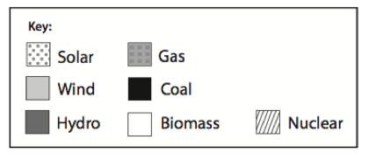
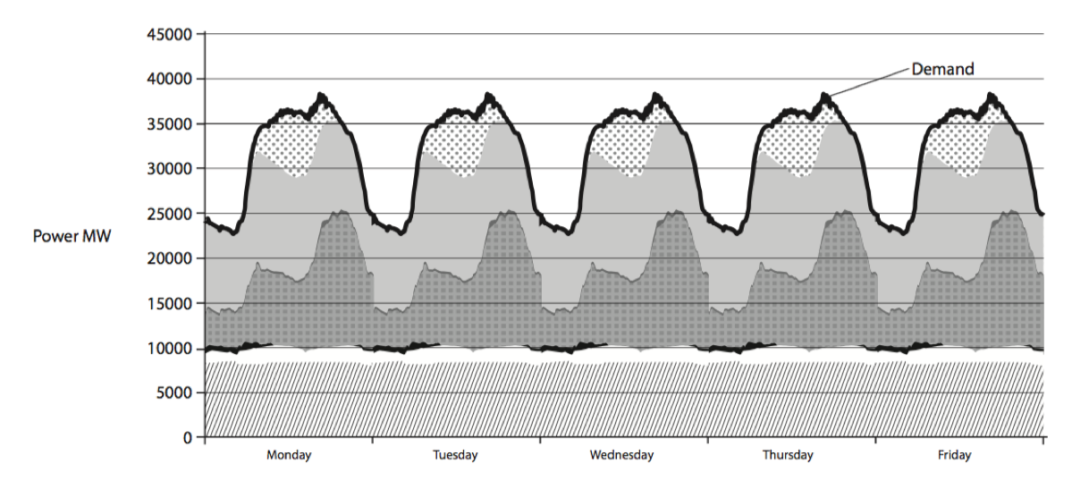
(i) Which of these is the best explanation of why the power output has peaks and troughs?
- There is more wind during the day.
- Gas is cheaper overnight.
- There is a bigger demand during the day.
- It is colder in winter.
(ii) Which type of source is the biggest contributor?
- renewables
- fossil fuels
- nuclear
- other
(iii) Which of these is the best explanation for the difficulty of relying on renewables alone?
- Solar and wind power depend on the weather.
- The Sun is not hot enough in the UK.
- Wind farms tend to be offshore.
- Gas fired power stations can be sited anywhere.

Multiple choice question answers

1. D
2. A
3. C
4. C
5. A
6. (i) C
(ii) A
(iii) D
(iv) A
(v) D
(vi) B
(vii) B
7. (i) D
(ii) B
8. B
9. C
10.(i) A
(ii) D
11. A
12. (i) C
(ii) B
(iii) A

